***PAAREES PERFUMES***

***Christian Diors***

***FOR MEN***

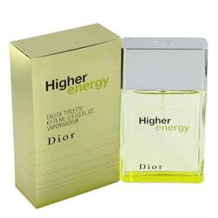

# *Higher Energy*

***Description***

Higher Energy by Christian Dior Cologne. Experience the rush of Higher Energy for men. Launched by the lauded Christian Dior design house in 2003, this energetic fragrance is masculine and full of life. It brings together an intriguing blend of melon, juniper berries and grapefruit to create a perfectly sweet and spicy aroma. Mint and musk combine to add the perfect finishing touch. Recommended for daytime use, Higher Energy is ideal to use in the morning to feel on top of your game throughout the day.